User Guide

# Introduction

Voterboat is a full-featured iOS voting system for UNT’s Student Government Association. The system allows students to cast votes for school elections, all from their mobile device. Voterboat also contains an administrative web interface, which allows administrators to create elections, add candidates, approve voters, view election statistics, and more. Our goal is to make the voting process extremely simple, hopefully motivating more students to participate in future school elections. Voterboat will also incorporate social sharing to Twitter and Facebook to help increase the virality of an election.

# Tutorial

This tutorial will give a walkthrough of the iOS application and admin web portal. We used AxureRP to create the prototype and wireframes. The admin portal was created in PHP, HTML, CSS, Javascript, and MySQL.

## iOS App

### Splash Screen – Create an Account – Log In

After downloading the app, users will be brought to the following screen. From this view, users can create an account, log in, or view the Privacy Policy and/or Terms of Use.

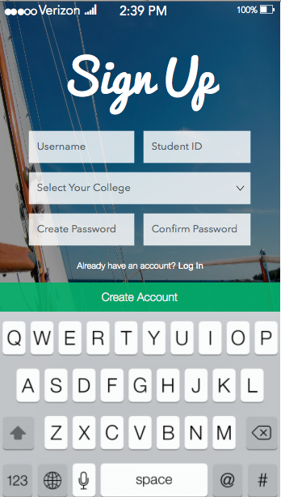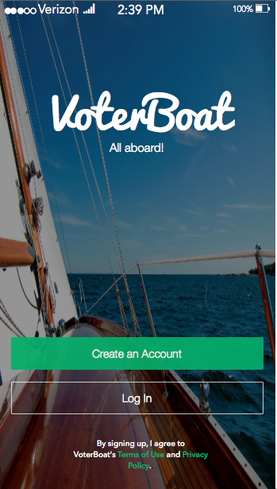

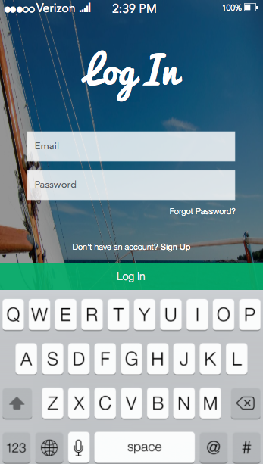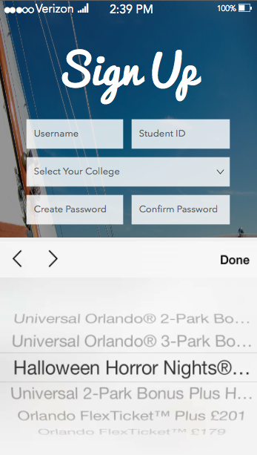

After users tap on “Create an Account”, the “Create an Account” view will transition from the left. This is where users input a username, student I.D., college, password and password confirmation. The college field will use the iOS picker wheel in order to display the colleges (we found photo from Universal Studios to show the picker wheel).

### My Votes

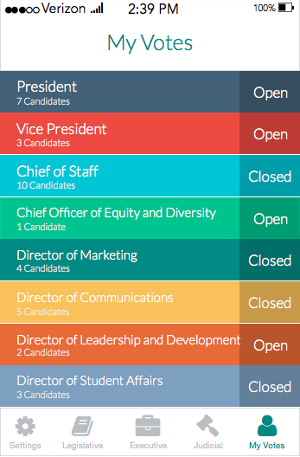After creating an account or logging in, the app will transition to the “My Votes” tab. This is displayed by the different color on the “My Votes” icon. This tab will show a list of elections you participated in as well as the status: whether they are open or closed. Open elections allow users to change their vote.

### Branches

The tab bar (at the bottom of the screen) will contain icons and labels for each of the three branches of government. Users are able to navigate to each branch to view the elections with the tap of a button.

### Executive Branch Elections

All three branch tabs will work in the same manner. Here is how to navigate through and use the executive branch functionality:

Clicking on the briefcase icon will show the “Executive Branch” view. On this view, users can view all of the elections in an intuitive, visually appealing list.

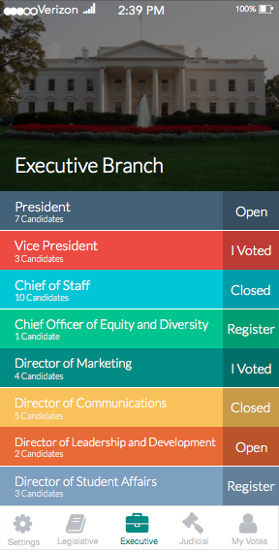

## 

Shown above is the “Executive” screen. The list view displays the position of each poll, the number of candidates, and the status/option. Here are the definitions of each of the statuses/options:

* Register: the user is able to register for the election
* Open: the election is ongoing and the user has already registered
* Closed: the election has ended
* I Voted: the user has casted a vote

### Individual Election

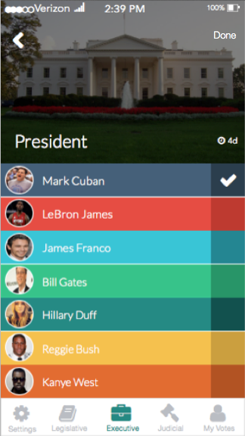If the user is registered for a specific election, tapping on an individual election will navigate to the detailed election view shown below.

Tapping on the darker squares on the right side of each candidate’s name will submit a vote. The time is shown above the first candidate’s selection box. When the user wants his/her vote to be finalized, he/she will tap done. Tapping done will bring up the UIActionSheet for sharing on Facebook or Twitter.

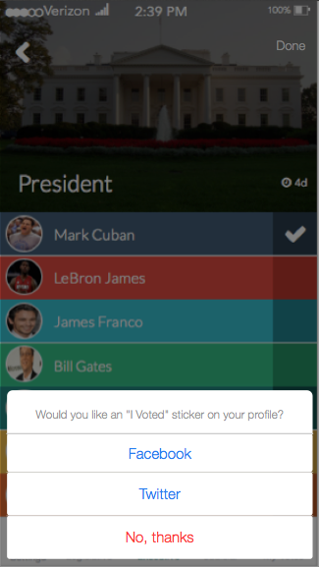

Because users can allow every tweet to go to their Facebook profiles through the Twitter settings, Voterboat allows users to select one network. The post/tweet says, “I just voted in the election, _________.” This keeps privacy while engaging the social media friends and followers.

### Candidate’s Profile

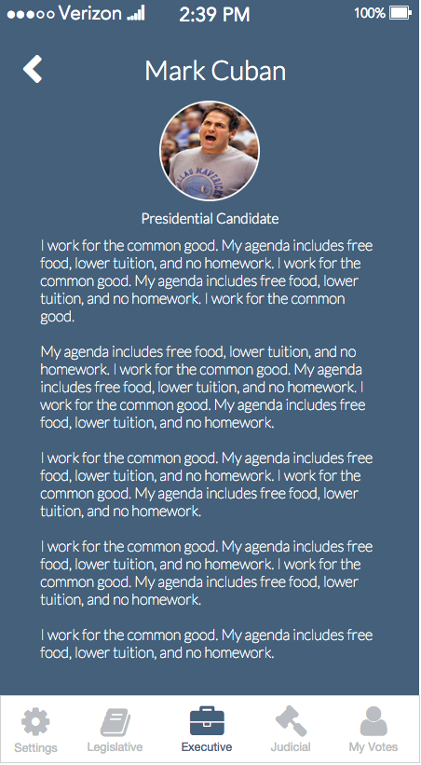Tapping on the candidate name will direct to the candidate’s profile. The profile includes the candidate’s name, profile photo, position running for and background information. This is where candidates can sell themselves before elections.

If the user has not registered to vote, the detailed election view will not show candidates or voting options.

### Registration

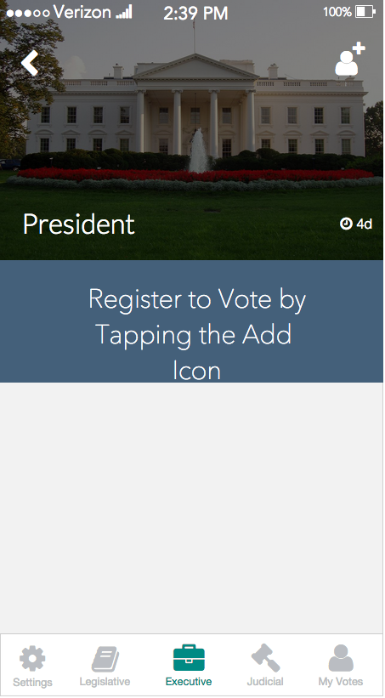Users can register for voting privileges or for candidacy by tapping the add icon in the navigation bar.

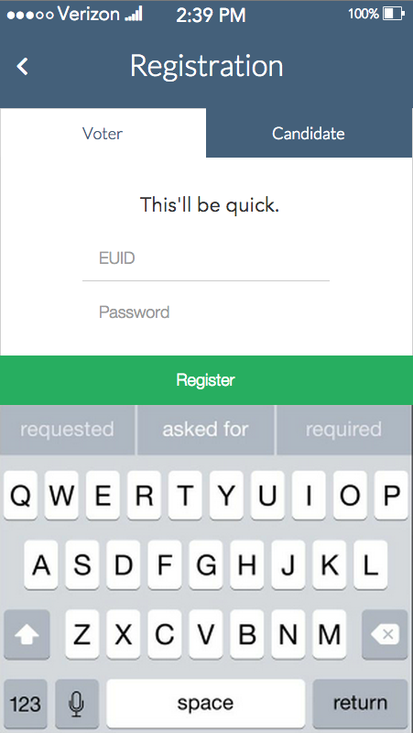

The default state is the registration to vote. This requires the user’s EUID and Password. If the user is looking to register for candidacy, he/she can tap on the “Candidate” tab. Tapping on this will bring up the Candidate registration view (Shown on the next page).

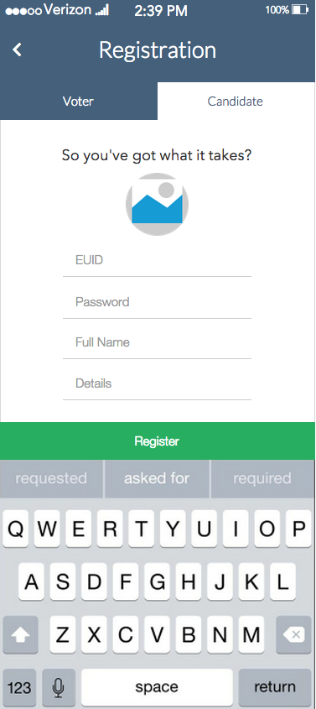

To register for candidacy, the system requires a profile photo, EUID, password, full name, and a details/background information section. This is where candidates can sell themselves prior to elections.

### Student Statistics Portal

Voterboat allows students to login through the web portal. Students will be able to see the vote distribution from the previous 24 hours. Because we are advocates for our users privacy, users will not be able to see a broken down version by candidate. The Voterboat team will separate the bars by gender if time allows. Here is a screenshot of the student web portal:

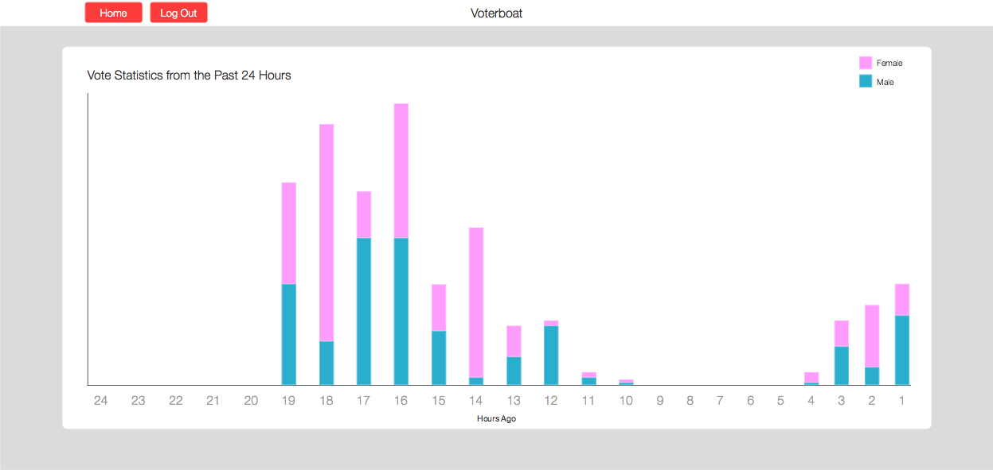

# Admin Web Panel

Voterboat provides an Administrative Panel that allows administrators to create, edit, and remove system data. Below are instructions to help administrators perform the most common tasks in Voterboat.

## Creating the Master Admin

Voterboat requires one administrator to receive “master permissions.” This admin will have access to more controls such as creating and managing administrators.

To create the master admin, go to [www.voterboat.me](http://www.voterboat.me) and click on the “Create Master Admin” button. Next, complete the form with your desired username, password, and system password (provided to you by Voterboat).

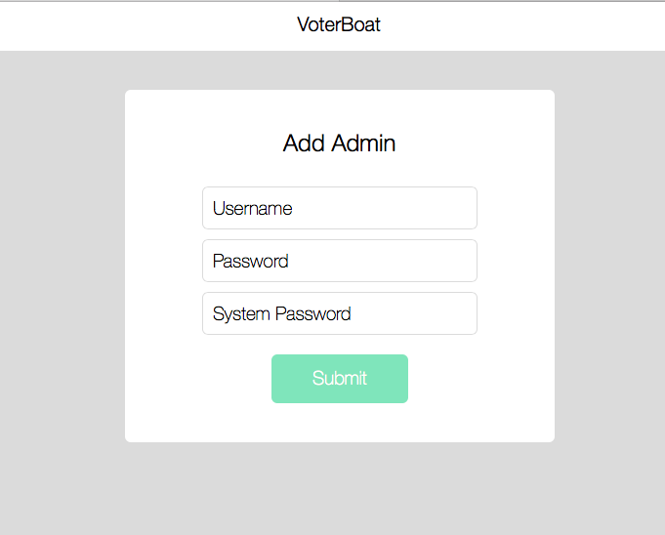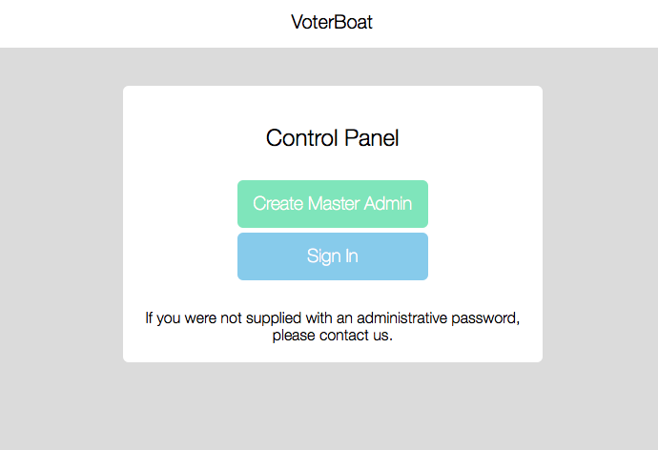

**Figure 1.1 –** home screen **Figure 1.2 –** add master admin screen

## Signing In

After creating your “Master Admin”, you can sign into your account by completing the form on the sign in screen.

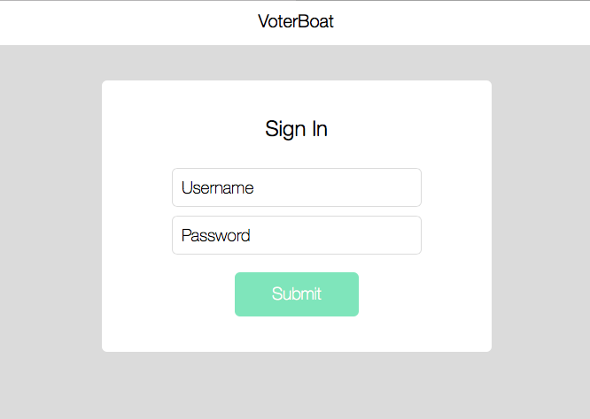

**Figure 1.2 –** sign in screen

## Admin Dashboard

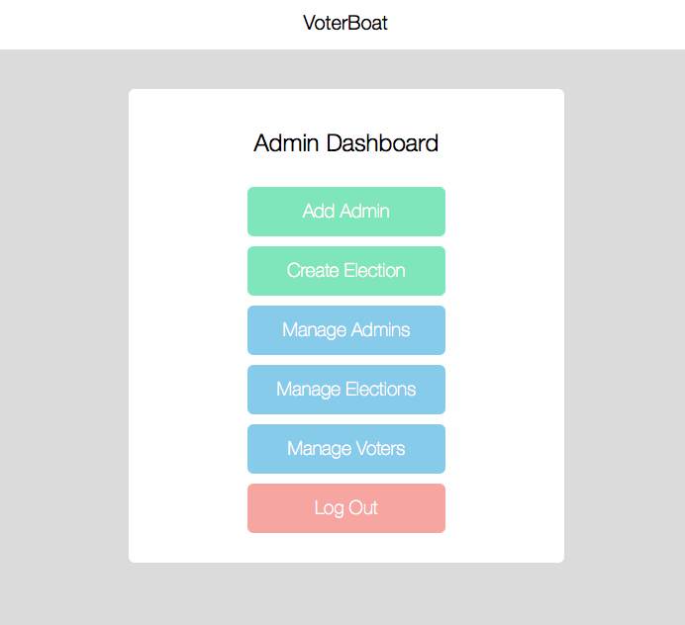After signing in, you will be presented with the Admin Dashboard. This is a simple screen that provides administrators with a list of administrative options. If a user is recognized as a “Master Admin”, they will be able to access more options such as create and manage admins.

**Figure 1.3 –** admin dashboard menu options

## Creating More Admins

To add more administrators, click on the “Add Admin” button on the Admin Dashboard. Complete the form by providing a desired username and password for the new administrator.



**Figure 1.4 –** add admin screen

## Managing Admins

As time progresses, your administrators may change. To remove an admin, click on the “Manage Admins” button from the Admin Dashboard. Next, locate the admin in the list and click on the “Remove” button.

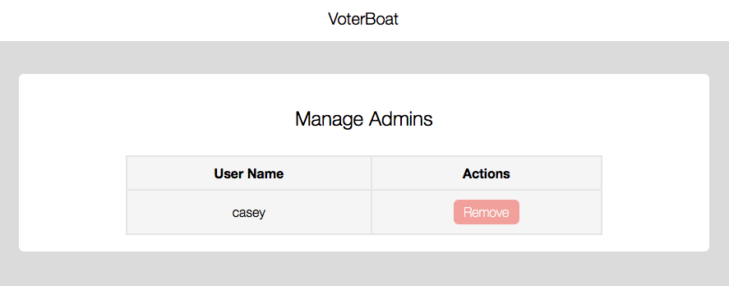

**Figure 1.5 –** manage admins screen

## Creating Elections

To create an election, click on the “Create Election” button on the Admin Dashboard. Next, provide an election name and click on the “Submit” button.

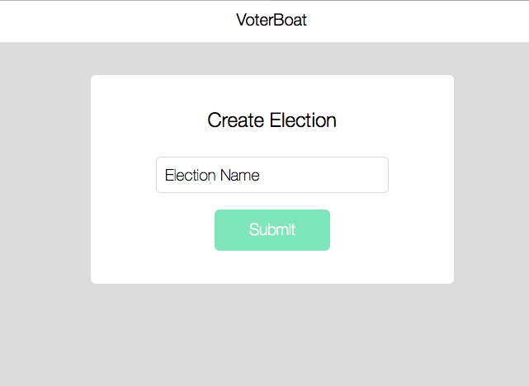

**Figure 1.6 –** create election screen

## Managing Elections

After creating an election, you may wish to add candidates, open the election, or delete the election. To manage elections, click on the “Manage Elections” button on the Admin Dashboard. From here you will see a list of elections, as well as common actions to perform on the elections. In addition, clicking on the results will direct to a plethora of statistical data. Voterboat allows admins to see the vote distribution from the previous 24 hours. Because we are advocates for our users privacy, users will not be able to see a broken down version by candidate.

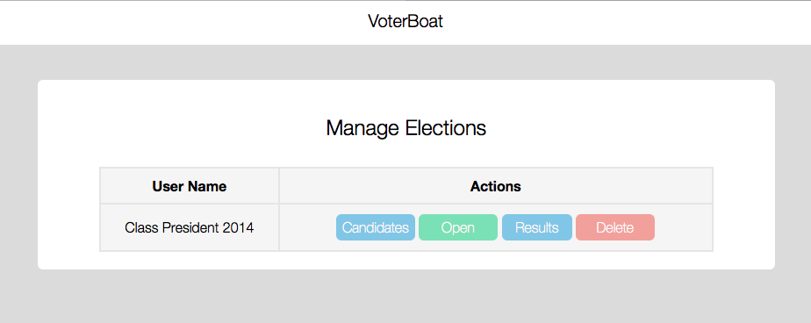

**Figure 1.7 –** manage elections screen

## Managing Election Candidates

To manage election candidates, click on the “Candidates” button from the “Manage Elections” screen. From here an admin is able to remove current candidates from an election or add new candidates by student ID number.

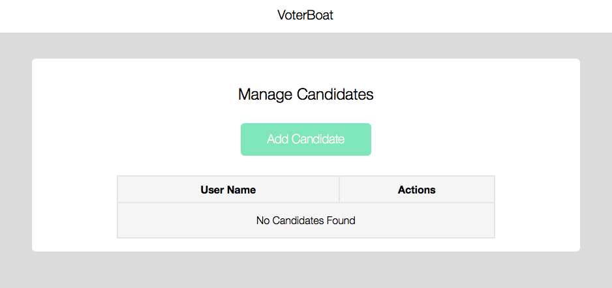

**Figure 1.8 –** manage candidates screen

## Manage and Approve Voters

To manage voters, click on the “Manage Voters” button on the Admin Dashboard. This will allow you to view all pending voters or all voters. Clicking on “Pending Voters” allows you to approve or deny student voters while clicking on “All Voters” lets you remove students from the system.

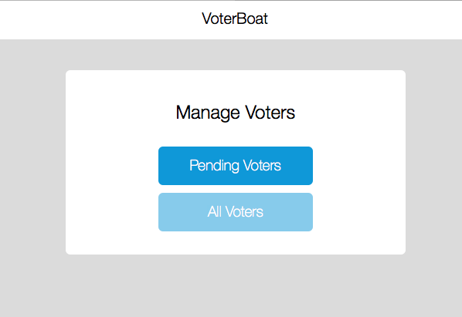

**Figure 1.9 –** manage voters screen

# Conclusion

Now that you have learned more about Voterboat’s capabilities, you are ready to get started! This document has outlined Voterboat’s key features, as well as how to perform some of the basic functions of the service. We hope that Voterboat simplifies the voting process and enables many more students to participate in future school elections!